Konkurs Poezji Obcojęzycznej
Strona, na której znajdziecie wiele śmiesznych wierszy, wraz z nagraniami, wymową : https://poetry4kids.com/poems/
Przykładowe wiersze: My cat is a ninja, Pizza Pizza I love you, albo I think my dad is Dracula
Inne wiersze w języku angielskim dla klas 0-4 SP:
Caterpillar by Christina Rossetti  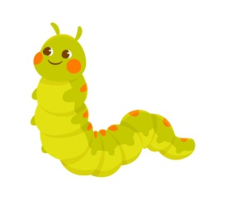  Brown and furry  Caterpillar in a hurry,  Take your walk  To the shady leaf, or stalk,  Or what not,  Which may be the chosen spot.  No toad spy you,  Hovering bird of prey pass by you;  Spin and die,  To live again a butterfly. | Two Little Dicky Birds  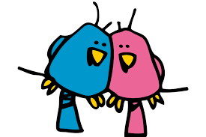  Two Little Dicky Birds,  Sat upon a wall.  One named Peter,  The other named Paul,  Fly away Peter.  Fly away Paul.  Come back Peter!  Come back Paul!!
The itsy bitsy spider  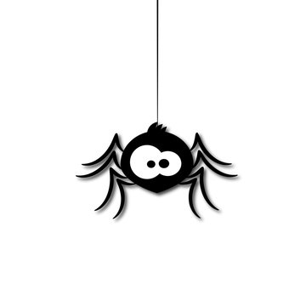  The itsy bitsy spider went up the water spout.  Down came the rain, and washed the spider out.  Up came the sun, and dried up all the rain,  and the itsy bitsy spider went up the spout again. | Rabbit by Mary Ann Hoberman  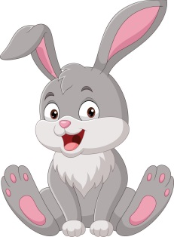  A rabbit  Bit  A little bit  An itty-bitty  Little bit of beet  Then bit  By bit  He bit  Because he liked the taste of it
“Baa, Baa, Black Sheep”  Baa, baa, black sheep,  Have you any wool?  Yes sir, yes sir,  Three bags full.  One for the master,  One for the dame,  And one for the little boy  Who lives down the lane | 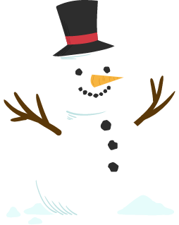  Snowball by Shel Silverstein  I made myself a snowball  As perfect as could be.  I thought I'd keep it as a pet  And let it sleep with me.  I made it some pajamas  And a pillow for its head.  Then last night it ran away,  But first it wet the bed.
I’m a Little Teapot by George Harold Sanders  I’m a little teapot  Short and stout  Here is my handle  Here is my spout  When I get all steamed up  Hear me shout  “Tip me over  and pour me out!”  I’m a clever teapot,  Yes, it’s true  Here let me show you  What I can do  I can change my handle  And my spout  Just tip me over and pour me out!  Rabbit by Mary Ann Hoberman  A rabbit  Bit  A little bit  An itty-bitty  Little bit of beet  Then bit  By bit  He bit  Because he liked the taste of it  White Sheep  White sheep, white sheep,  On a blue hill,  When the wind stops,  You all stand still.  When the wind blows,  You walk away slow.  White sheep, white sheep,  Where do you go? | Twinkle, Twinkle Little Star  Twinkle, twinkle, little star,  How I wonder what you are.  Up above the world so high,  Like a diamond in the sky.  Twinkle, twinkle, little star,  How I wonder what you are!  When the blazing sun is gone,  When he nothing shines upon,  Then you show your little light,  Twinkle, twinkle, all the night.  Twinkle, twinkle, little star,  How I wonder what you are!  Then the traveler in the dark  Thanks you for your tiny spark;  How could he see where to go?  If you did not twinkle so.  Twinkle, twinkle, little star,  How I wonder what you are!  In the dark blue sky you keep,  While you through my window peep,  And you never shut your eye,  Till the sun is in the sky,  Twinkle, twinkle, little star,  How I wonder what you are!  There Once Was A Man With A Beard— George Harold Sanders  There was an Old Man with a beard,  Who said “It is just how I feared,”  Two Owls and a hen,  For Larks and a wren,  Have all built their nests in my beard
About the Teeth of Sharks by John Ciardi  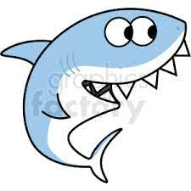  The thing about a shark is—teeth,  One row above, one row beneath.  Now take a close look. Do you find  It has another row behind?  Still closer—here, I’ll hold your hat:  Has it a third row behind that?  Now look in and…Look out! Oh my,  I’ll never know now! Well, goodbye. | Once I caught a fish alive  One, two, three, four, five.  Once I caught a fish alive.  Six, seven, eight, nine, ten.  Then I let it go again.  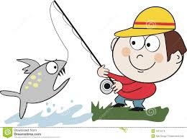  Why did you let it go?  Because it bit my finger so.  Which finger did it bite?  This little finger on the right.  One, two, three, four, five.
Mary Had a Little Lamb  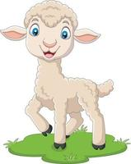  Mary had a little lamb,  Its fleece was white as snow,  And ever where that Mary went,  The lamb was sure to go;  It followed her to school one day,  Which was against the rule;  It made the children laugh and play,  To see a lamb at school,  And so the teacher turned it out,  But still itlingered near,  And waited patiently about,  Till Mary did appear;  “Why does the lamb love Mary so?  The eager children cried;  The “ Why, Mary love the lamb, you know.”  The teacher did reply; | Child Of The Days  Monday’s child is fair of face,  Tuesday’s child is full of grace,  Wednesday’s child is full of woe,  Thursday’s child has far to go.  Friday’s child is loving and giving,  Saturday’s child works hard for a living,  Sunday’s child is fun and entertaining.  All the days have a child that’s amusing.  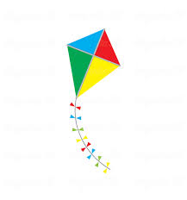  My Kite— Graham Cunningham  My kite flies high,  I wonder how and why.  With a long tail and wings,  See how my kite swings!  Holding its thread in my hand,  I feel so happy and grand.
The Crocodile - Lewis Carroll  How doth the little crocodile  Improve his shining tail,  And pour the waters of the Nile  On every golden scale!  How cheerfully he seems to grin,  How neatly spreads his claws,  And welcomes little fishes in,  With gently smiling jaws! | At the Zoo by William Makepeace Thackeray  First I saw the white bear, then I saw the black;  Then I saw the camel with a hump upon his back;  Then I saw the grey wolf, with mutton in his maw;  Then I saw the wombat waddle in the straw;  Then I saw the elephant a-waving of his trunk;  Then I saw the monkeys—mercy, how unpleasantly they smelt!
Hey Diddle Diddle  Hey diddle diddle,  The Cat and the fiddle,  The Cow jumped over the moon,  The little Dog laughed to see such sport,  And the Dish ran away with the Spoon  "Hickory, dickory, dock," – by Mother Goose  Hickory, dickory, dock,  The mouse ran up the clock;  The clock struck one,  And down he run,  Hickory, dickory, dock. | Jack And Jill  Jack and Jill  Went up the hill  To fetch a pail of water,  Jack fell down  And broke his crown  And Jill came tumbling after.  Up Jack got  And home did trot  As fast as he could caper,  Went to bed  To mend his head  With vinegar and brown paper.
Easter Is Here  Easter time at last is here  Bunnies, chickies, let us cheer  (clap and cheer)  Easter Bunny hops with joy  Eggs for every girl and boy  (hop around)  Easter time at last is here  Bunnies, chickies, let us cheer  Teddy bear, teddy bear  Teddy bear, teddy bear, turn around,  Teddy bear, teddy bear, touch the ground,  Teddy bear, teddy bear, reach up high,  Teddy bear, teddy bear, touch the sky,  Teddy bear, teddy bear, bend down low,  Teddy bear, teddy bear, touch your toes,  Teddy bear, teddy bear, go to bed,  Teddy bear, teddy bear, rest your head,  Teddy bear, teddy bear, turn out the lights,  Teddy bear, teddy bear, say "good night". | The Days of the Months  Thirty days hath September,  April, June, and November;  February has twenty-eight alone.  All the rest have thirty-one,  Excepting leap-year—that’s the time  When February’s days are twenty-nine.

Przykładowe wiersze w języku angielskim dla klas 4-8 SP:

How Not to Have to Dry the Dishes - Shel Silverstein  If you have to dry the dishes  (Such an awful, boring chore)  If you have to dry the dishes  (’Stead of going to the store)  If you have to dry the dishes  And you drop one on the floor—  Maybe they won’t let you  Dry the dishes anymore.  Peter Piper  Peter Piper picked a peck of pickled peppers.  A peck of pickled peppers Peter Piper picked.  If Peter Piper picked a peck of pickled peppers,  Where’s the peck of pickled peppers Peter Piper picked? | Learning - Judith Viorst  I’m learning to say thank you.  And I’m learning to say please.  And I’m learning to use Kleenex,  Not my sweater, when I sneeze.  And I’m learning not to dribble.  And I’m learning not to slurp.  And I’m learning (though it sometimes really hurts me)  Not to burp.  And I’m learning to chew softer  When I eat corn on the cob.  And I’m learning that it’s much  Much easier to be a slob.  I Hear You Call, Pine Tree by Yone Noguchi  I hear you call, pine tree, I hear you upon the hill, by the silent pond where the lotus flowers bloom, I hear you call, pine tree.  What is it you call, pine tree, when the rain falls, when the winds blow, and when the stars appear, what is it you call, pine tree?  I hear you call, pine tree, but I am blind, and do not know how to reach you, pine tree. Who will take me to you, pine tree?
Bed In Summer  In winter I get up at night  And dress by yellow candle-light.  In summer, quite the other way,  I have to go to bed by day.  I have to go to bed and see  The birds still hopping on the tree,  Or hear the grown-up people’s feet  Still going past me in the street.  And does it not seem hard to you,  When all the sky is clear and blue,  And I should like so much to play,  To have to go to bed by day? | Rhyme - Elizabeth Coatsworth  I like to see a thunderstorm,  A dunder storm,  A blunder storm,  I like to see it, black and slow,  Come stumbling down the hill.  I like to hear a thunderstorm,  A plunder storm,  A wonder storm,  Roar loudly at our little house  And shake the window sills!
Song by T. S. Eliot  When we came home across the hill  No leaves were fallen from the trees;  The gentle fingers of the breeze  Had torn no quivering cobweb down.  The hedgerow bloomed with flowers still,  No withered petals lay beneath;  But the wild roses in your wreath  Were faded, and the leaves were brown. | ‘From a Railway Carriage’ by Robert Louis Stevenson  Faster than fairies, faster than witches,  Bridges and houses, hedges and ditches;  And charging along like troops in a battle,  All through the meadows the horses and cattle:  All of the sights of the hill and the plain  Fly as thick as driving rain;  And ever again, in the wink of an eye,  Painted stations whistle by …
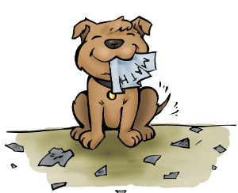  My dog ate my homework. — Kenn Nesbitt  My dog ate my homework.  That mischievous pup  got hold of my homework  and gobbled it up.  My dog ate my homework.  It’s gonna be late.  I guess that the teacher  will just have to wait.  My dog ate my homework.  He swallowed it whole.  I shouldn’t have mixed it  with food in his bowl.  Wind On The Hill  No one can tell me,  Nobody knows,  Where the wind comes from,  Where the wind goes.  It's flying from somewhere  As fast as it can,  I couldn't keep up with it,  Not if I ran.  But if I stopped holding  The string of my kite,  It would blow with the wind  For a day and a night.  And then when I found it,  Wherever it blew,  I should know that the wind  Had been going there too.  So then I could tell them  Where the wind goes…  But where the wind comes from  Nobody knows.  The Sisters  Sing me a song—  What shall I sing?—  Three merry sisters  Dancing in a ring,  Light and fleet upon their feet  As birds upon the wing.  Tell me a tale—  What shall I tell?—  Two mournful sisters,  And a tolling knell,  Tolling ding and tolling dong,  Ding dong bell.  My brother ate my smartphone  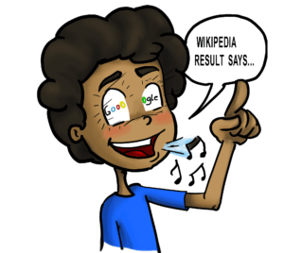  My brother ate my smartphone.  Although it might sound strange,  he swallowed it and, bit by bit,  his brains began to change.  He started getting smarter.  He grew so shrewd and wise.  And I could see that, suddenly,  a light was in his eyes.  He knew as much as Google.  His IQ was off the charts.  I’d never seen someone so keen,  with such astounding smarts.  He solved the toughest problems  with simplicity and ease,  and calculated answers  with unrivaled expertise.  It seems he’s now a genius,  a perfect brainiac.  But I don’t care, or think it’s fair.  I want my smartphone back.  — Kenn Nesbitt | Eletelephony - Laura Elizabeth Richards  Once there was an elephant,  Who tried to use the telephant—  No! No! I mean an elephone  Who tried to use the telephone—  (Dear me! I am not certain quite  That even now I’ve got it right.)  Howe’er it was, he got his trunk  Entangled in the telephunk;  The more he tried to get it free,  The louder buzzed the telephee—  (I fear I’d better drop the song  Of elephop and telephong!)  Little Jack Horner  Little Jack Horner  Sat in the corner  Eating his Christmas pie,  He stuck in his thumb  And pulled out a plum and said  “What a good boy am I  What a good boy am I”  Little Miss Muffet  Sat on her tuffet,  Eating her curd and whey;  Along came a spider,  And sat down beside her,  Frightened Miss Muffet away, oh yeah  Frightened Miss Muffet away  Little Jack Horner  Sat in the corner  Eating his Christmas pie,  He stuck in his thumb  And pulled out a plum and said  “What a good boy  What a good boy  What a good boy am I”  Sick by Shel Silverstein  “I cannot go to school today,"  Said little Peggy Ann McKay.  “I have the measles and the mumps,  A gash, a rash and purple bumps.  My mouth is wet, my throat is dry,  I’m going blind in my right eye.  My tonsils are as big as rocks,  I’ve counted sixteen chicken pox  And there’s one more--that’s seventeen,  And don’t you think my face looks green?  My leg is cut--my eyes are blue--  It might be instamatic flu.  I cough and sneeze and gasp and choke,  I’m sure that my left leg is broke--  My hip hurts when I move my chin,  My belly button’s caving in,  My back is wrenched, my ankle’s sprained,  My ‘pendix pains each time it rains.  My nose is cold, my toes are numb.  I have a sliver in my thumb.  My neck is stiff, my voice is weak,  I hardly whisper when I speak.  My tongue is filling up my mouth,  I think my hair is falling out.  My elbow’s bent, my spine ain’t straight,  My temperature is one-o-eight.  My brain is shrunk, I cannot hear,  There is a hole inside my ear.  I have a hangnail, and my heart is--what?  What’s that? What’s that you say?  You say today is. . .Saturday?  G’bye, I’m going out to play!”

